**Excel Assignment – 13**

**Dataset:**

**https://docs.google.com/spreadsheets/d/1IRSEnmgz8Ro276-GslknRNk0zlrB5CZH1YrnT71kqFM/edit?usp=sharing**

**Use the above dataset and answer the following questions.**

1. **What is the total amount of stationery bought from Madhya Pradesh?**

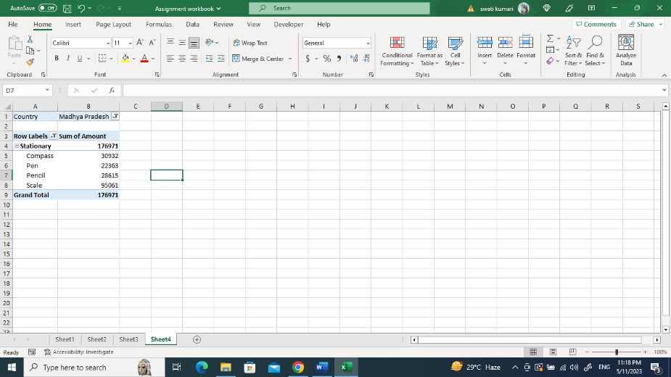

1. **What is the total count of stationery bought from Tamil Nādu?**

1. **What is the total amount spent on footwear?**

1. **What is the total amount of money spent on stationary in July?**

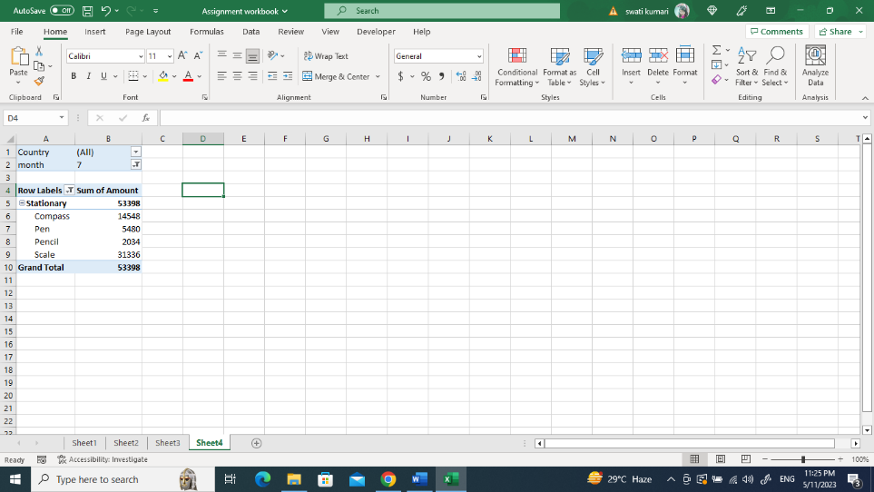

1. **What is the count of footwear that is coming from Delhi?**

